Region H Healthcare Preparedness Coalition Bylaws
Date of Approval: November 20, 2013
Date of Adoption: November 20, 2013
Revised: January 11, 2018
Revised: October 28, 2019

Article 1 Name and Geographical Area

Section 1 Name

A. The name of this organization shall be the Region H Healthcare Preparedness Coalition (also referred to “the Healthcare Coalition” or “the Coalition” within this document.)

Section 2 Geographical Area

- The geographical areas included in the Coalition shall be Baldwin, Bleckley, Dodge, Hancock, Jasper, Johnson, Laurens, Montgomery, Pulaski, Putnam, Telfair, Treutlen, Twiggs, Washington, Wheeler, Wilcox, and Wilkinson counties within the state of Georgia.
- Region H is mixed geographically with a combination of rural and urban counties; however, it is predominantly rural.

Article 2 Mission Statement & Purpose

Section 1 Mission Statement

The Region H Healthcare Preparedness Coalition will support the local healthcare community and other response agencies to jointly plan for and respond to man-made or natural emergencies, by promoting intra-regional cooperation and sharing of resources.

Section 2 Purpose

A. To coordinate the emergency preparedness efforts and plans of its member organizations. B. To develop regional procedures for the management of healthcare system response to emergencies and/or disasters based on deliverables from the Centers for Disease Control and/or the Assistant Secretary for Preparedness and Response.
- To exist as a vehicle to establish priorities for grant funding to member organizations for healthcare preparedness efforts.
- To establish and maintain a system of resources and services that includes five (5) core missions of HPP. These systems and resources will assist in coordinating healthcare response operations, deploying emergency response teams, mobilizing delivery systems, providing specialty logistical support, and supporting planning and preparedness activities.
- Fulfilling stated performance expectations of the Centers for Disease Control and Prevention’s (CDC) PHEP grant and the Assistant Secretary for Preparedness and Response (ASPR) grant, specifically those laid out in the both Preparedness Capabilities documents: Health Care Preparedness Capabilities

Public Health Preparedness Capabilities

Article 3 Coalition Structure

Section 1
- The Healthcare Coalition shall consist of the following:
  - Coalition Membership
    - Active Coalition Members
    - Inactive Coalition members
    - Invited non-members
  - Executive Committee
  - Planning Committee
  - Finance Director- UGA
- See Attachment A, Organizational Chart and Region H Communications Flowchart, provided to demonstrate coalition organization and communication throughout coalition in the event of an incident or emergency.
Article 4 Membership

Section 1 Eligibility of funding, purchasing, maintenance or requesting assets
- Only those member organizations that are considered Active Coalition Members (Article 4, Section 2 C) will be eligible to apply for and receive grant funding from the Coalition to be able to purchase or maintain coalition assets. Coalition funding can only be used for the purchase of coalition assets or maintenance of previously purchased coalition assets. Coalition funds can also be used for sponsorship of Active Coalition members for conferences, trainings and related expenses. Active coalition members can request to purchase assets by completing the Region H Request for Coalition Fund Purchase Form. Active Coalition members will be selected by the Executive Committee to attend conferences and will be required to fill out the applicable forms from the Coalition Handbook.
- All funding decisions will be voted on by the Executive Committee.
- Coalition assets cannot be reserved in advance of a disaster or emergency. If and when a facility has an event that requires them to request an asset from the Coalition, the request should be made by calling the Coalition Facilitator or Coalition Coordinator. All circumstances will be reviewed on a case by case basis and agreed upon by the Coalition Executive Committee.

Section 2 Coalition Membership
- Membership to the Coalition is open to all healthcare organizations and jurisdictions that exist in the Coalition geographical area (Article 1, Section 2) and that agree to work collaboratively on emergency preparedness and response activities.
- If there is uncertainty as to whether an organization qualifies as a health care organization or support agency whether the organization’s jurisdiction falls within the geographical area, a majority vote by Active Coalition Members will determine.
- Active Coalition Members are those Coalition member organizations who have established voting rights as in Article 8, Section 1 B. Active coalition members will be given priority for asset allocation based on available resources and prioritize needs at the discretion of the RCH.
- Inactive Coalition Members are those Coalition member organizations who have failed to establish voting rights per Article 8, Section 1 B.
- Member organizations will assign one to three representatives to attend Coalition meetings. The representative(s) should have the authority to represent and speak on behalf of the organization. Each organization represented will receive one vote regardless of the number of staff representing the facility.
- Organization representatives are eligible to fill elective Coalition positions (Executive Committee).
- Individuals may represent more than one member organization but must clearly be acting in the interests of each represented organization independently. (Sign in must reflect all organizations represented by individual.)
- If an individual representing an organization withdraws from participation, the member organization must appoint a new representative within 90 days.
- Organizational resignation must be submitted in writing to the Coalition.

Section 3 Membership Responsibilities

- Provide representation at Coalition meetings and activities and ensure attendance.
- Participate in collaborative regional preparedness planning.
- Participate in the development of surge capacity plans, inter-organizational agreements, and collaborative emergency response plans.
- Contribute to meeting Coalition priorities, goals, and contractual deliverables.
- Vote on questions placed before the membership.
- Respond to regional emergencies and disasters in collaboration with other members.
- Participate in sub-committees and workgroups as requested by members or individuals and organized under the umbrella of the Coalition. These sub-committees and workgroups may exist and function temporarily or long-term, as needed. H. Actively participate as a member of the Healthcare Coalition.
- Designate a primary and alternate Emergency Program Manager to serve as a liaison with Healthcare Coalition and delegating to those individuals the authority to speak for your organization during a major emergency, disaster or exercise. Contact information should be shared and updated with the RCH or Coalition Facilitator annually, unless changes occur throughout the year.
- Participating in Coalition-facilitated mutual aid including the provision of materiel and human resources.
- Participate in the development of a Coalition-wide Hazard Vulnerability Analysis (HVA).
- Achieve and monitor compliance with current federal National Incident Management System (NIMS) guidance.
- Develop, publish and maintain an organization-wide Emergency Management Plan in compliance with current federal Hospital Preparedness Program (HPP) guidance.
- Capture and report the status of organizational resources during major emergencies, disasters and exercises including available beds, staff, materiel and equipment resources.
- Facilitate the participation of organization staff (clinical and non-clinical) in essential Coalition training and education programs.
- Participate in at least one (1) Coalition-facilitated preparedness and planning workshop each year, unless an active event occurs that requires the member’s facility to activate the EOC.
- Participate in at least one (1) Coalition-facilitated emergency or disaster exercise each year.
- Participate in state and federal disease surveillance, investigation and control activities at the request of the Georgia Department of Public Health or the Centers for Disease Control and Prevention.

Section 4 Membership Roster
- A roster of member organizations will be available upon request and posted on GHA911 and the Region H website annually by the Health District’s Healthcare Facilitator.
- Section 5 Invited Non-Members
Region H Health Coalition collaborating organizations which are deemed not eligible for membership may nevertheless be invited to attend Coalition meetings and activities. Such invited organizations may fully engage in Coalition discussions and other activities but shall have no vote.
Article 5 Planning Committee

Section 1 Composition and Appointment
The Coalition Planning Committee will consist of two to three members who are selected by The Executive Committee. Nominations should be made in a fashion to maintain a multi-disciplinary composition on the planning committee. The number of planning members that exist on the committee must be two to three people at all times based on the requirements given by the UGA planning committee.

Section 2 Planning Committee Duties
- The Planning Committee will facilitate the HSEEP required activities preparing for and including the full-scale exercise for the Region H Coalition.
- The Planning Committee will receive grant funding requests from the Coalition membership and submit to the Executive Committee.
Article 6 Executive Committee

Section 1 Composition
- An interdisciplinary Executive Committee comprised of a minimum of six Active Coalition Members will be formed.
  - A representative from the Regional Coordinating Hospital and District 05-1 Public Health are permanent members on the Executive Committee.
  - The remaining four representatives can be selected from:
    - Emergency Medical Service (Air or Ground)
    - Local Emergency Management Agency
    - Long term care facilities
    - Hospice, Home Health and/or outpatient services
    - Non-RCH hospitals
    - Other healthcare entities
- Executive Committee members must designate a proxy in writing (letter or email) to act in their absence.

Section 2 Election
- To be eligible to stand for election to the Executive Committee, an individual must have attended 2 of the last 3 Coalition meetings.
- Elections for membership to the Executive Committee will occur during the last Coalition meeting of the fiscal year (July 1 – June 30).
- A Nominating Committee may be established to provide recommendations for election to the Executive Committee.
- Any new vacancies on the executive committee will be filled as soon as possible by vote of the present Active Coalition members.
- The current executive committee may place nomination(s) for vacant position(s) on the agenda of the last meeting of the fiscal year for action by the membership.
- Nominations from the floor to stand for Executive Committee may be made by Active Coalition members during the last meeting of the fiscal year.
- Nominations should be made in a fashion to maintain the multidisciplinary composition of the Executive Committee.
- Executive Committee members will serve for two years. However, there is no limit to the number of successive terms an Executive Committee member may serve.
- Special election may be called at any meeting to fill prematurely vacated Executive Committee position(s).

Section 3 Executive Committee Duties

- The RCH’s HCC is the Chairperson and the Facilitator is the Co-chair.
- Review and approve meeting agendas
- Monitor Coalition projects and contract deliverables
- Review, update and approve plans.
- Prioritize funding and budget allocations including the review of funding requests and the approval or disapproval of such requests.

Section 4 Decision Making
A quorum is required to hold a vote. A quorum will consist of half of the members of the Executive Committee. In the event that only four members are present, the Chair may vote. Decisions of the executive committee will be made by consensus. If no consensus can be reached, then such question will be deferred to the next meeting of the Executive Committee.
Electronic votes and teleconferences will constitute attendance required to meet the quorum.

Section 5 Coalition Chairperson

- Designated as the Chairperson as long as serving as the RCH’s HCC.
- Chairs Executive Committee and Coalition Meetings.
- Works closely with the Co-chair on current issues concerning the Coalition.
- Available to the membership for information exchange concerning the Coalition.
- Acts in the general interests of the Coalition and its membership.
- Assumes additional duties from time to time and as appropriate to facilitate the function of the Coalition.
- The chairperson shall also serve as the official representative and spokesperson of the Coalition.
- Chairperson will be a non-voting member except in the event of a tie.

Section 6 Coalition Co-chair
- Designated as the Co-chair as long as serving as the HCF.
- Acts for the Chairperson in his/her absence.

Article 7 Finance Reporting
The Finance Reporting of the Coalition will exist to document receiving of and disbursement of funds as allocated by the Executive Committee. This duty will be filled by the Regional Coordinating Hospital’s HCC with supporting documentation from UGA.
Article 8 Voting and Conducting Business

Section 1 Voting Eligibility
- Voting is restricted to Active Coalition members.
- Attendance by a representative of the member organization at two (2) of the last three (3) Coalition meetings, exercises or Coalition sponsored events, defines Active Coalition members with the right to vote. In the event a member attends a Coalition sponsored event outside of Region H, the individual will be responsible to provide proof of attendance.
- Participate in at least one (1) Coalition-facilitated emergency or disaster exercise each year.
- Designated representatives must be present in order to vote unless a special vote is called by the executive committee (see Article 8 section 3). The Chairperson shall only vote in the event of a tie.

Section 2 Votes
- Each member organization present shall have one vote.
- Proxy voting is allowed. All proxies must be submitted to the Executive Committee in writing (letter or email).
- Voting shall be determined by a simple majority.

Section 3 Special Votes
The Coalition may hold special votes that occur outside of the regular Coalition meetings by email, conference call or other method deemed appropriate by the Executive Committee. When such votes are conducted, there shall be a reasonable opportunity (five business days) for all active members to have input prior to the vote, unless otherwise stated.

Section 4 Conducting Business
- One representative from each of the following disciplines should be in attendance to conduct official Coalition business at a meeting (see section 4-C for absentee vote).
  - Emergency Medical Service
  - Emergency Management Agency
  - Long term care facility
  - Hospice and/or outpatient services
  - Non-RCH hospital
- Actions in a meeting shall be determined by a simple majority vote (excepting bylaw changes, see Article 9).
- If one representative from each discipline is not present at a meeting, business will take place under the condition that any motions that are put forth to a vote will be presented to absent Active Coalition members via special vote (see Article Section 3).
Article 9 Meetings

Section 1 Scheduling
- Coalition meetings will be scheduled at least quarterly.
- Executive committee will meet at least quarterly, in person or virtually.
- Planning Committee will meet when required by UGA planning team.
- Written notice and registration for all meetings shall be transmitted in advance of the meetings.

Section 2 Venue
Meetings will be held at locations convenient for members. Electronic (“Virtual”) meetings are allowed if available.

Section 3 Attendance
Meetings may be attended in person, by conference call or by other electronic means if available.

Section 4 Emergency meetings
Emergency meetings may be convened at the request of the Coalition Chairperson or Co-Chairperson. No business may be transacted at an emergency meeting except that pertaining to the emergency.
Article 10
Fiscal Duties and Responsibilities
The Healthcare Coalition serves to apply for, receive, and distribute various grants/funds to healthcare organizations in furtherance of promoting the preparedness and partnership of the Coalition. These funds or equipment or supplies may come from different sources and have specific guidelines that must be adhered to by recipients/participants that exceed the requirements for membership in the Coalition. Participating organizations understand and agree to abide by all external requirements placed upon funds, equipment of supplies they receive through the Healthcare Coalition. By electing to participate in any grant or program, a member organization agrees to fulfill all requirements including but not limited to training, exercise participation, inventory, recordkeeping, equipment maintenance and inspection, and maintaining resources for deployment and use by other regional members of the Coalition.
UGA will function as the primary agent for Coalition Funds. GHA (Georgia Hospital Association) will function as the primary agent for Ebola Funds. The RCH will function as the emergency fiscal agent for coalition funds to pass through for purchases and disbursements. The RCH’s HCC, as well as the HCF, shall be responsible for tracking all Coalition related expenditures directed by the membership. The record keeping shall be in accordance with generally accepted accounting practices.

Article 11 Amending the Bylaws
Amendment of these bylaws may take place at any meeting of the Coalition by a majority vote of all present Active Coalition Members provided a copy of such proposed amendment(s) are distributed to coalition in advance of such meeting, and attached to the written notice for that meeting.

Article 12 Indemnification and Limits of Liability
This Charter and Bylaws shall not supersede any existing mutual aid agreement or agreements. This Charter and Bylaws shall not be interpreted or construed to create an association, joint venture separate legal entity or partnership among the member bodies or to impose any partnership obligation or liability upon any Health Jurisdiction. Further, no member shall have any undertaking for or on behalf of, or to act as or be an agent or representative of, or to otherwise bind any other member body.
Any member shall not be required under this Charter to indemnify, hold harmless and defend any other member from any claim, loss, harm, liability, damage, cost or expense caused by or resulting from activities of any Coalition officers, employees, or agents acting in bad faith or performing activities beyond the scope of their duties. In the event of any liability, claim, demand, action or proceeding, of whatever kind or nature arising out of rendering of Emergency Assistance defined through this Charter, the member agrees to indemnify, hold harmless, and defend, to the fullest extent of the law, each signatory to this Charter, whose only involvement in the transaction or occurrence which is the subject of such claim, action, demand, or other proceeding, is the execution and approval of this Charter.
APPROVAL OF CHARTER and BYLAWS
Addendum: The Current Acting Executive Committee will remain in place until the last meeting of the 2013-2014 fiscal year, when a new Executive Committee is voted on by the Coalition.
The Charter and Bylaws were originally approved by a vote of the Acting Coalition Executive Committee.
Approval Date: November 20, 2013
The Charter and Bylaws were originally adopted by a vote of the Region H Healthcare Coalition membership.
Adoption Date: November 20, 2013
The Charter and Bylaws were most recently Revised by the Executive Committee for proposal to Coalition Membership: January 11, 2018.
The Charter and Bylaws were most recently approved and adopted by the Coalition Membership: January 16, 2018.
The Charter and Bylaws were most recently approved and adopted by the Coalition Membership: October 28, 2019.
The Charter and Bylaws were most recently approved and adopted by the Coalition Membership: January 28, 2020.
Attachment A: Organization Chart and Flow Chart
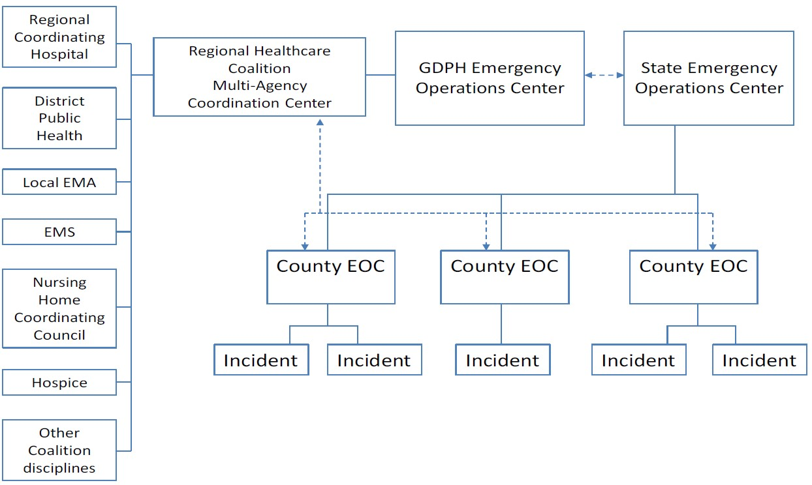

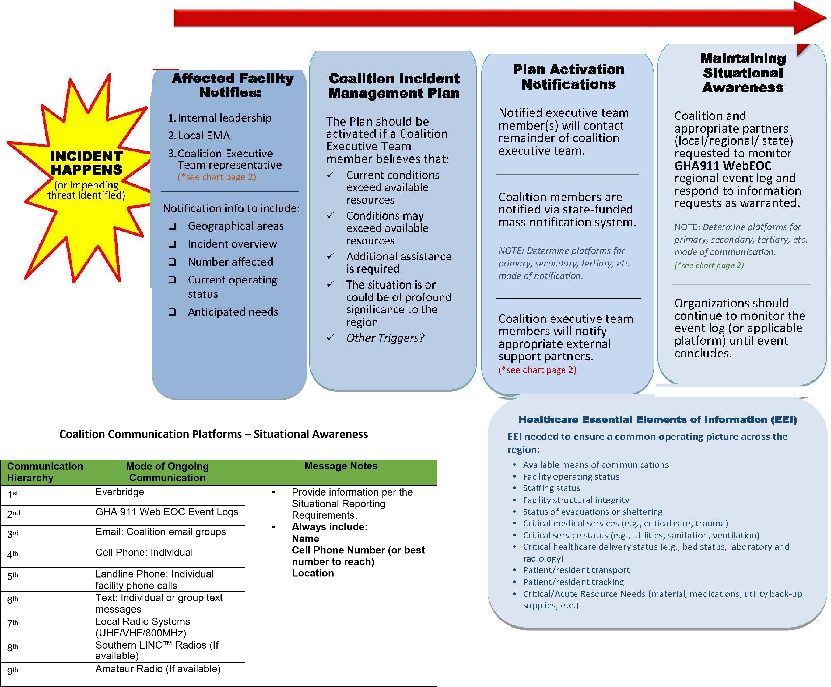
Healthcare Disciplines Contact Healthcare Coalition Executive Committee Representative  - Hospitals - Other Healthcare Disciplines (not represented below) Regional Coordinating Hospital (RCH)  • Public Health DPH District Emergency Coordinator DPH Healthcare Liaison  • Local Emergency Management Agencies Emergency Management Agency  • Nursing Homes Nursing Home  • Emergency Medical Services Emergency Medical Services (EMS)  Healthcare Coalition Contacts:  Regional Coordinating Hospital Coordinator (RCH) Lynn Grant Fairview Park Hospital Office Phone: 478.274.3194 Cell Phone: 478.230.3320 HCC Back Up Sherry Robbins Office Phone: 478.274.3764 Cell Phone: 478.290.7530 DPH District Emergency Coordinator Jodi Bazemore, SCHD 5-1 Office Phone: 478.275.6566 Cell Phone: 478.463.6543 DPH Healthcare Coalition Facilitator Megan Craft Office Phone:478.274.7778 Cell Phone:678.767.8891 EMA / EMS Bill Laird, Laurens County EMA / EMS / Fire Office Phone:478.275.9025 Cell Phone:478.595.4301 Hospice Michelle Bryan Office Phone: 478.220.3196 Cell Phone: 478.278.7195 Hospital / Emergency Management Expert Sherry Thomas, Carl Vinson VA Medical Center Office Phone: 478.272.1210 Cell Phone: 478.484.1274 Hospital Alaina Dykes, Bleckley Memorial Hospital Office Phone 478.934.6211 Cell Phone: 478.230.0507 Nursing Home Dawn Jones, Georgia War Veterans Home Office Phone: 478.445.5371 Cell Phone: 478.456.8610 | Coalition Executive Committee Representative Notifies the Following  Regional Coordinating Hospital (RCH) - GHA Emergency Preparedness Director (notifies other RCH’s) - GDPH Healthcare Preparedness Program Director  DPH District Emergency Coordinator - State on-call duty officer (855-377-4347) - District Health Director  Emergency Management Agency (EMA) - GEMA Area Field Coordinator - Appropriate First Responders  Nursing Home (NH) - Georgia Healthcare Association (GHCA) - Neighboring NH Council Coordinator  Emergency Medical Services (EMS) - Regional EMS Program Director - EMS agencies in affected region and/or neighboring regions
Coalition Member’s Executive Committee Representative Communication With Regional / State Partner

